|  |  |
| --- | --- |
| Name: | Class: |

**➀Complete and match.** Mark / 5

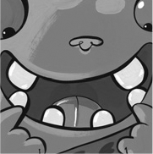 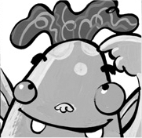 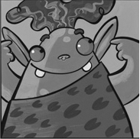 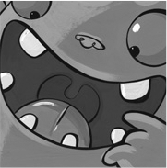 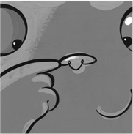 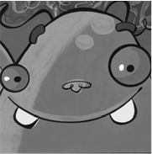

➊ n ose ➋ fac _ ➌ e _ rs

➍ mo _ th ➎ t _ _ th ➏ h _ ir

**➁Match.** Mark / 5

➊ I’ve got a long nose.

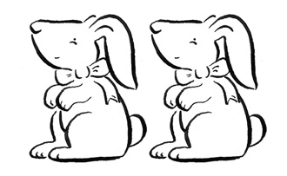

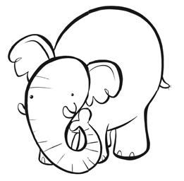

➋ We’ve got long hair.

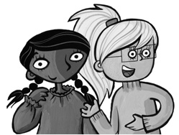 ➌ I’ve got a big eye.

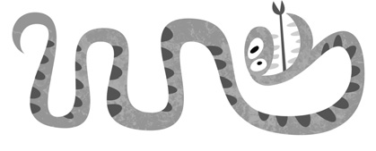

➍ We’ve got big ears.

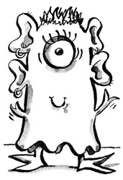

➎ I’ve got a big mouth.

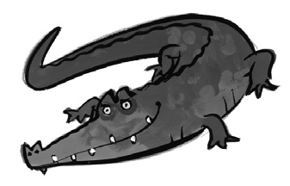

➏ I’m long and thin.

Total unit mark / 10