Name: | Class:

Write . Mark / 5

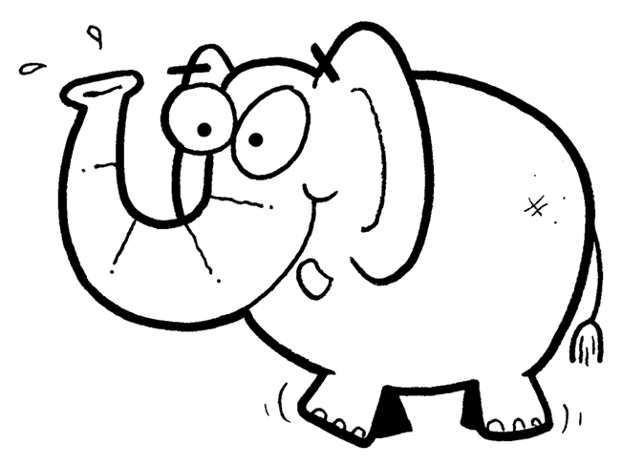
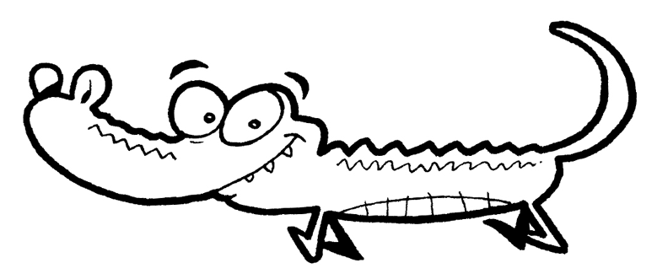
c r o c o d i l e _ _ _ _ _ _ _ _
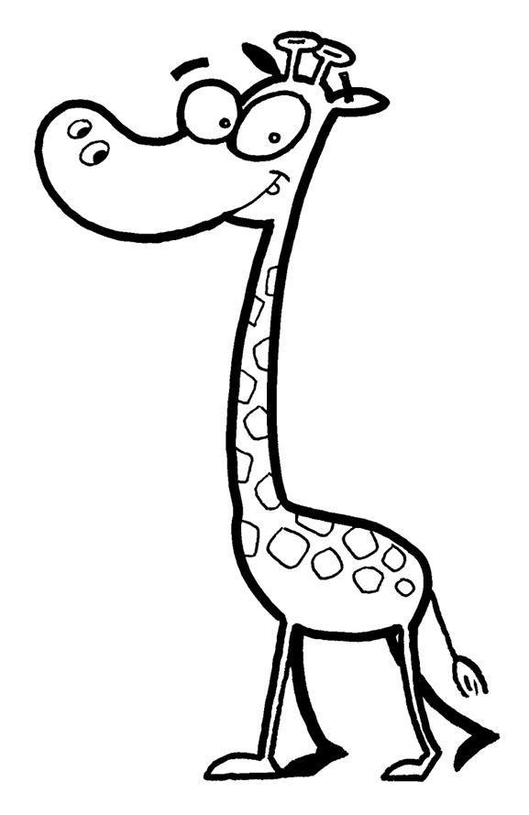

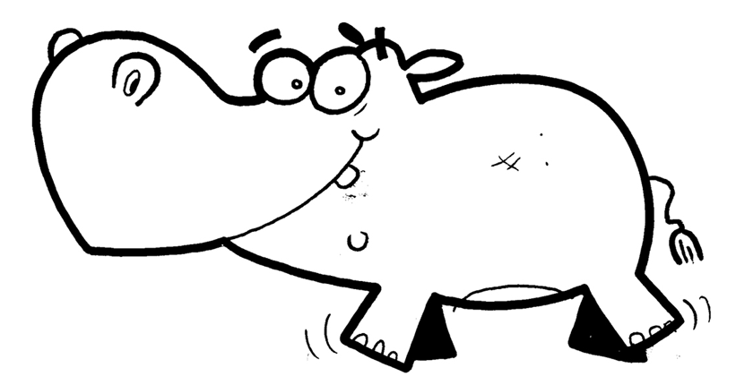
_ _ _ _ _ _ _ _ _ _ _ _

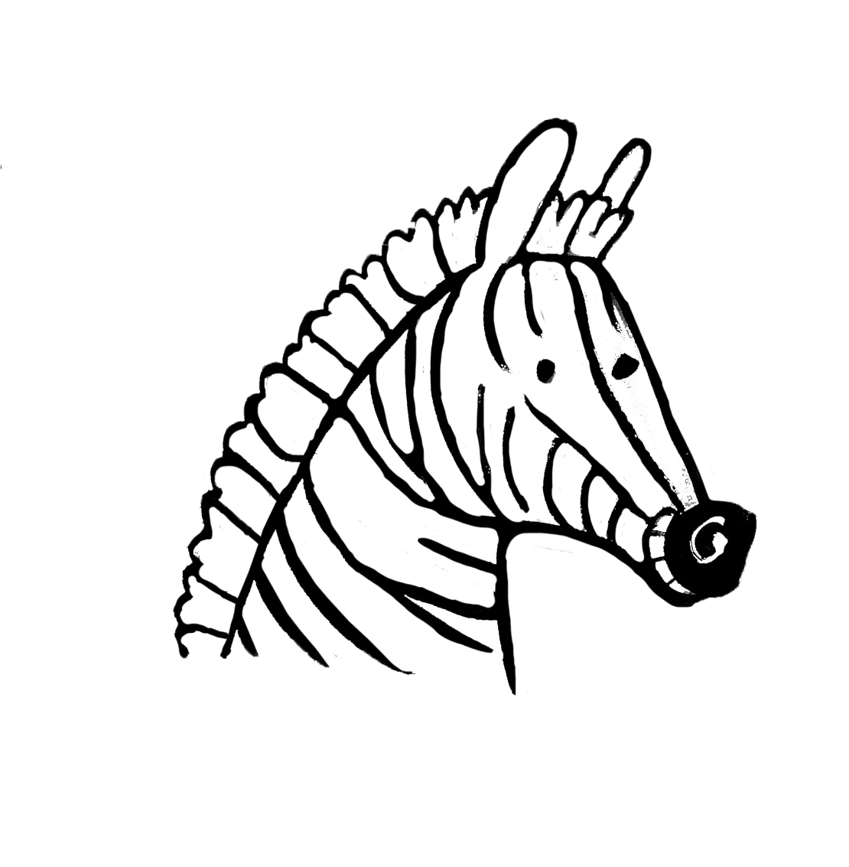
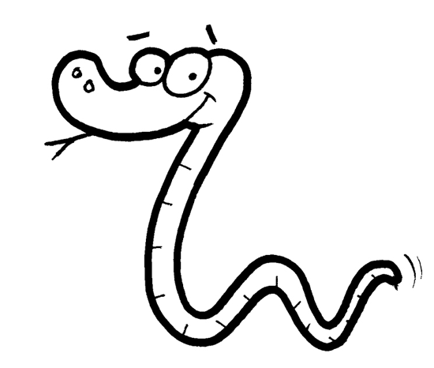

_ _ _ _ _ _ _ _ _ _

Look and circle. Mark / 5

They ’ve / haven’t got hands. They ’ve / haven’t got feet.
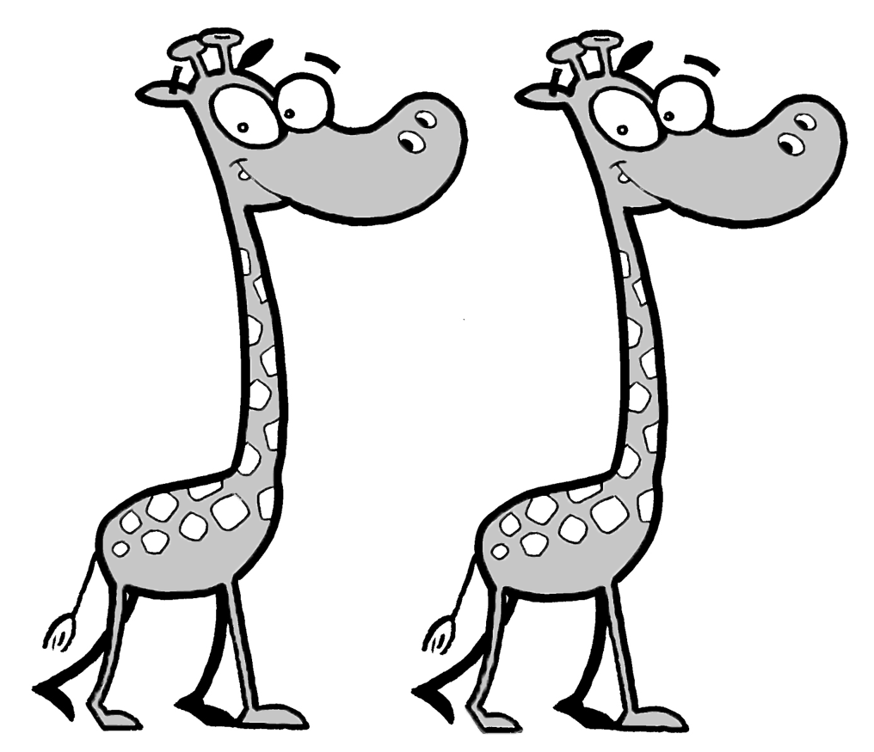
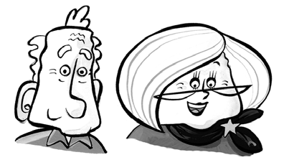

They ’ve / haven’t got teeth. They ’ve / haven’t got legs.
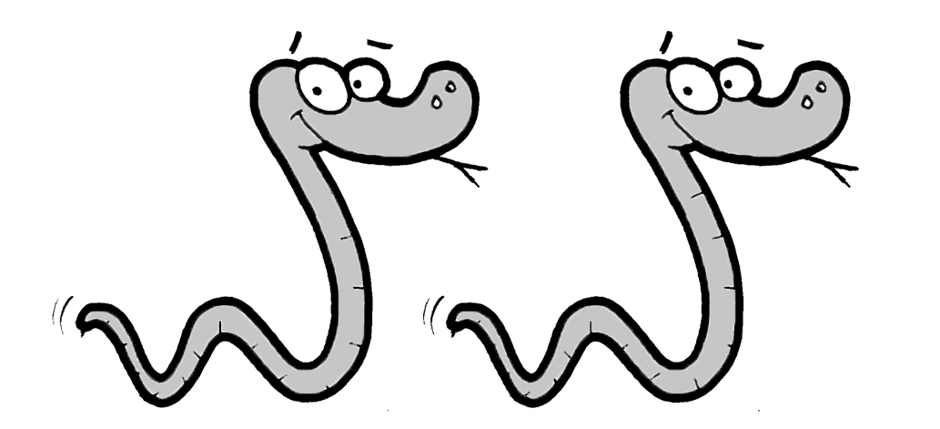
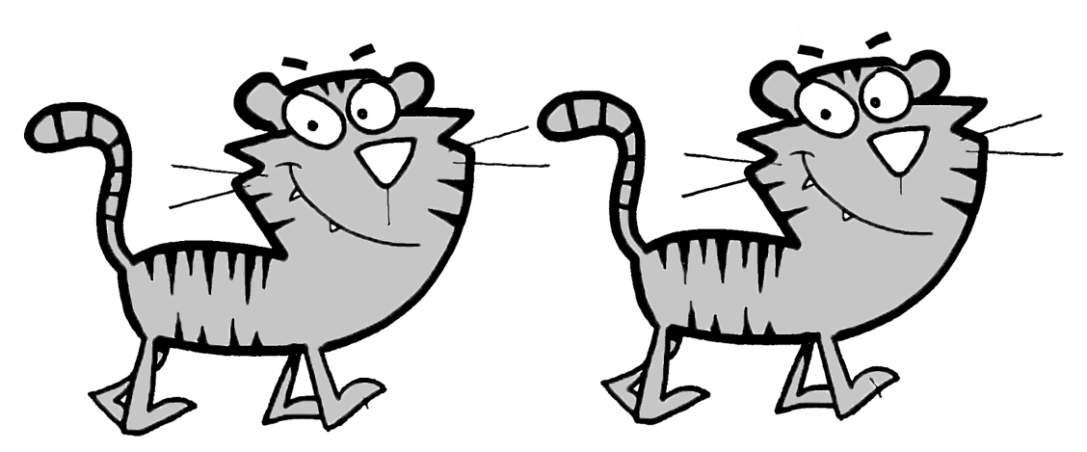

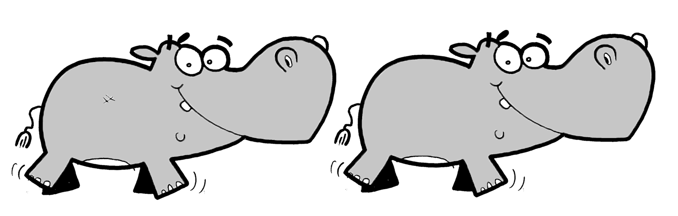
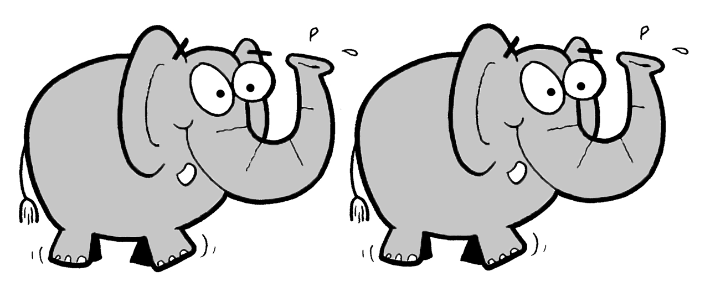
They ’ve / haven’t got arms. They ’ve / haven’t got tails.

Total unit mark / 10

