|  |  |
| --- | --- |
| Name: | Class: |

**➀Look and write.** Mark / 5



11 18 14

elevenfifteen twenty _____ _____ twelve

**➁Read and circle.** Mark. / 5

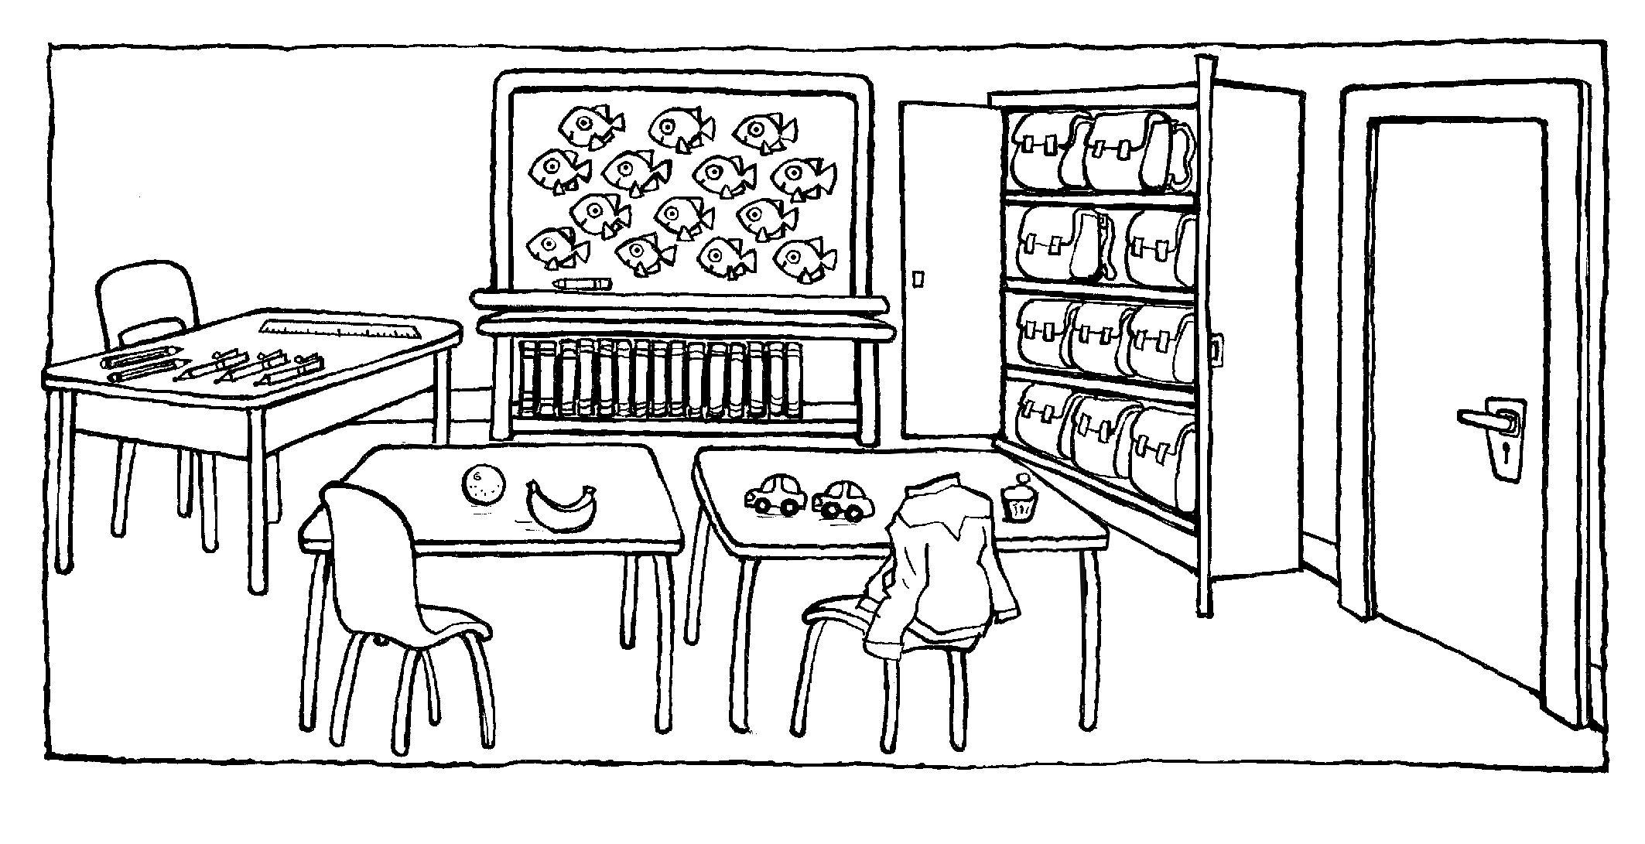

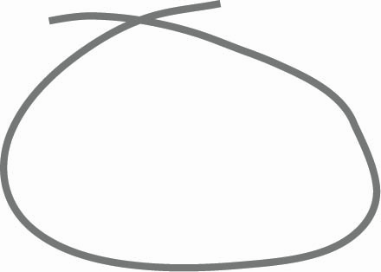

 ➊ There ‘s / are desks in the classroom.

➋ There is / are a cupboard in the classroom.

➌ There aren’t / isn’t a poster in the classroom.

➍ There ‘s / are a whiteboard in the classroom.

➎ There ’s / are a ruler in the classroom.

➏ There ‘s / are a bookcase in the classroom.

Total unit mark / 10