|  |  |
| --- | --- |
| Name: | Class: |

**➀Look and write the words.** Mark / 5

|  |
| --- |
| camera ~~lorry~~ computer game tablet robot watch |

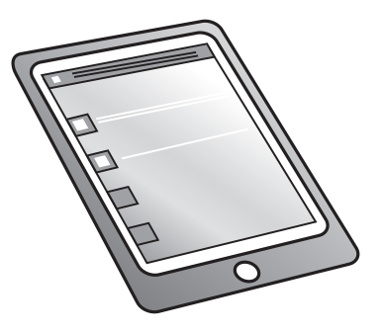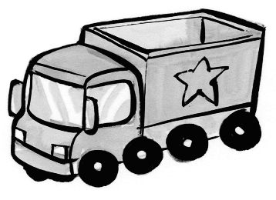

➊ lorry ➋ ___________

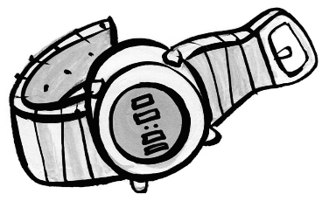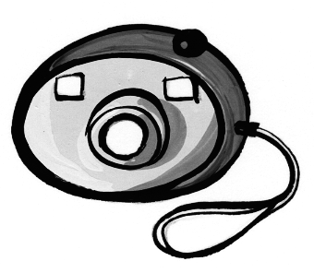

➌ ___________ ➍ ___________

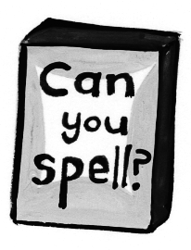

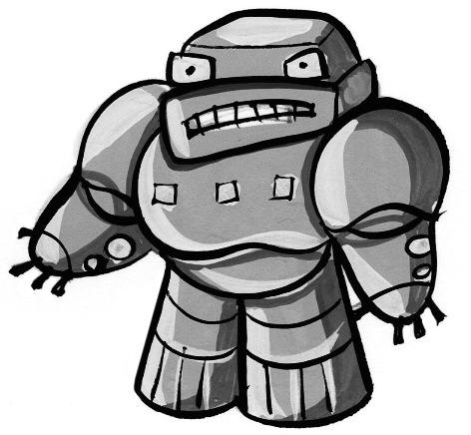

➎ ___________ ➏ ___________



**➁ Listen and draw lines.** Mark / 5

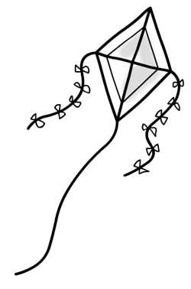

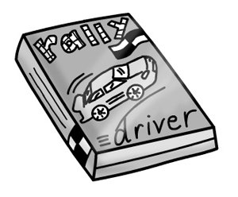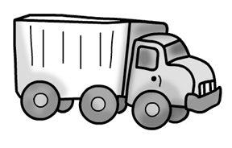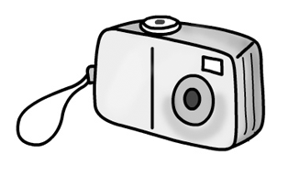

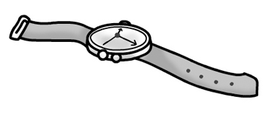



Rick Sam Ann Jill

Total unit mark / 10