|  |  |
| --- | --- |
| Name: | Class: |

**➀Read and write.** Mark / 5

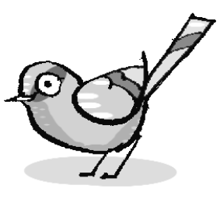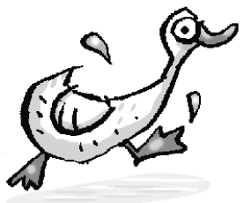

|  |
| --- |
| ~~ducks~~ sheep birds fish spiders goats |

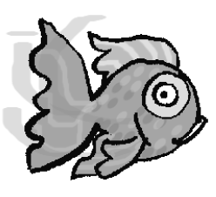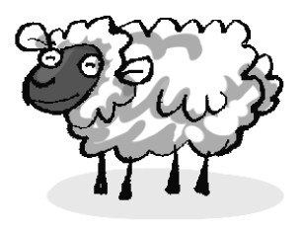 They can swim. ducks ________

They can fly. ________

They’ve got four legs. ________ ________

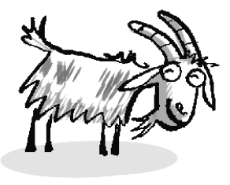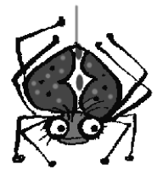 They’ve got eight legs. ________



**➁ Listen and tick (🗸) or cross (🗴).** Mark / 5



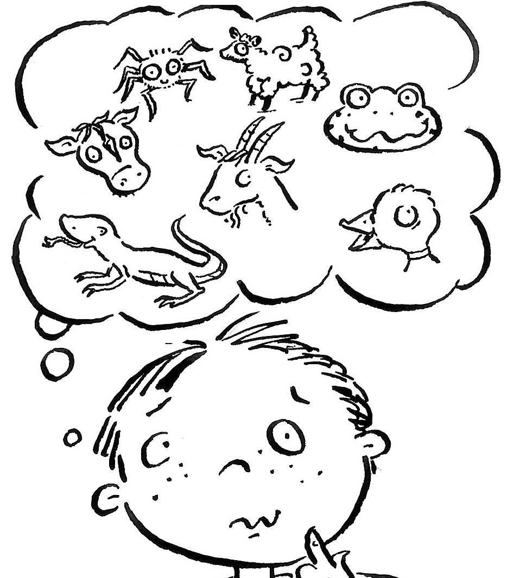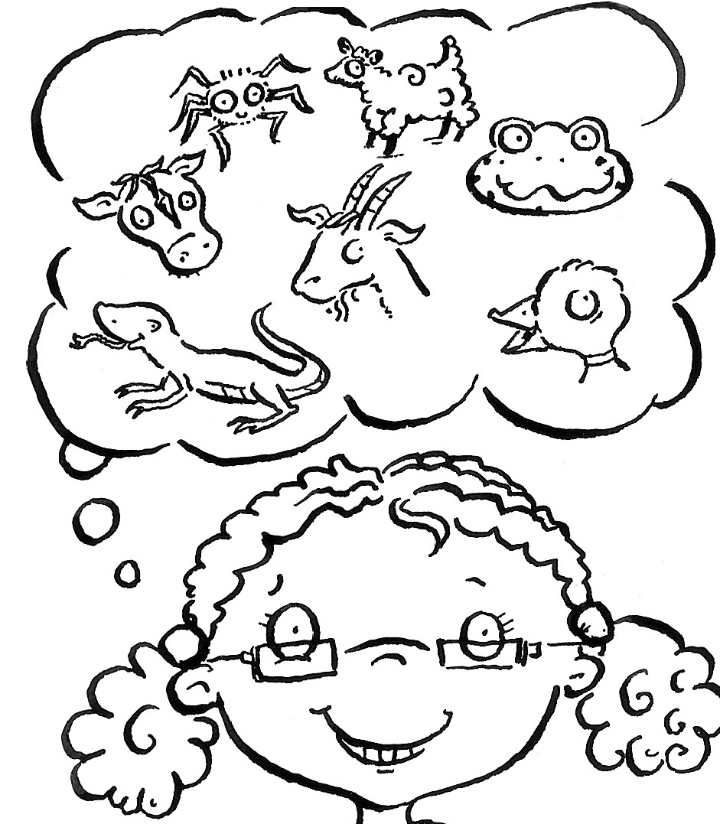









Total unit mark / 10