|  |  |
| --- | --- |
| Name: | Class: |

**➀Match and write.** Mark / 5

|  |
| --- |
| baseball basketball ~~badminton~~ hockey  table tennis football |

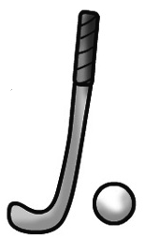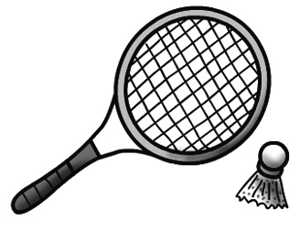

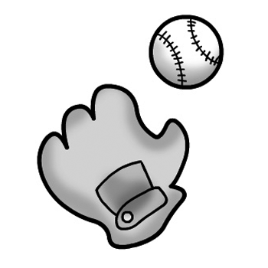➊ badminton  ➋ ____________

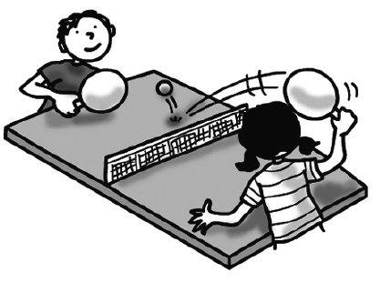

➌ ____________ ➍ ____________

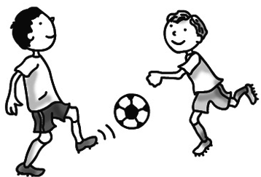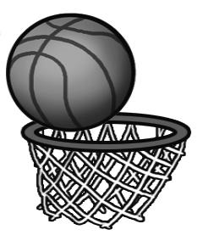

➎ ____________ ➏ ____________

**➁Read and circle.** Mark / 5



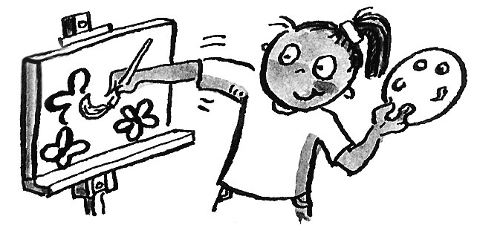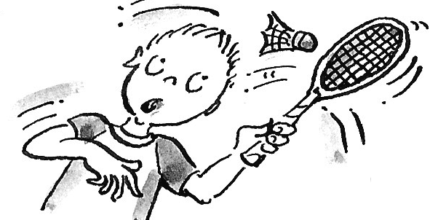➊ She like / likes painting. ➋ I don’t / doesn’t like badminton.

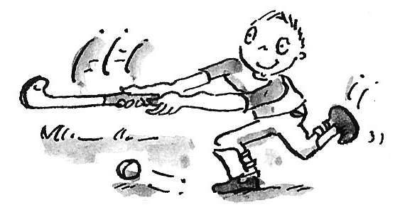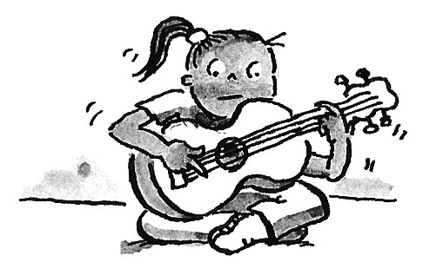➌ Does Nick like / likes hockey? ➍ Anna doesn’t like / likes playing the guitar.

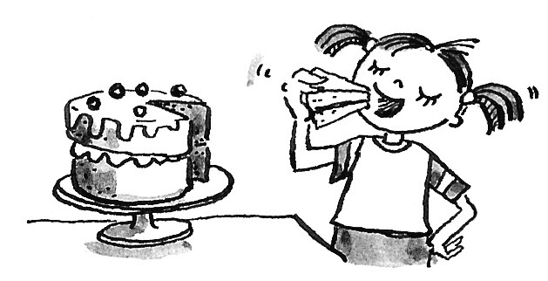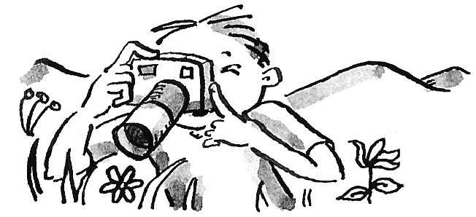➎ Tom likes take / taking photos. ➏ She likes eat / eating cake.

Total unit mark / 10