|  |  |
| --- | --- |
| Name: | Class: |

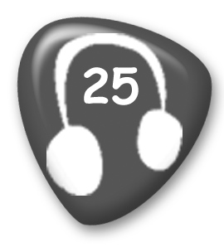

**➀ Listen and number.** Mark / 5

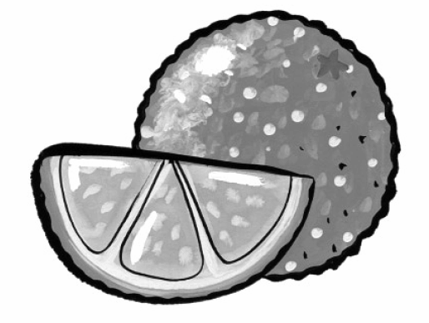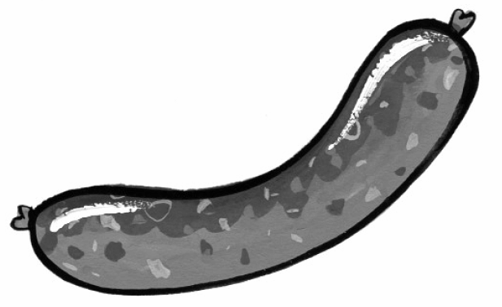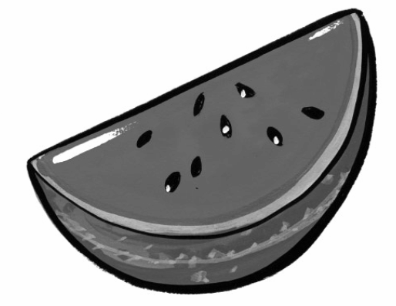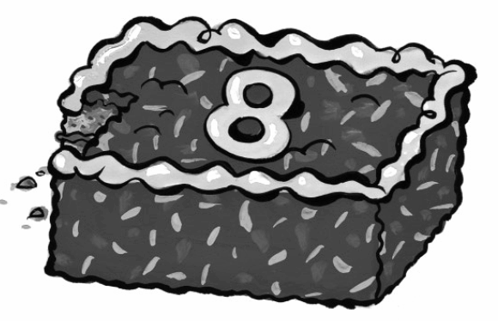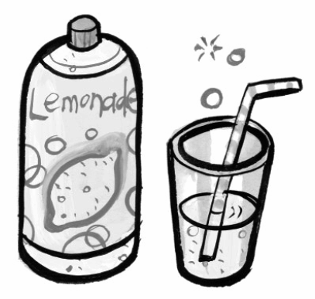

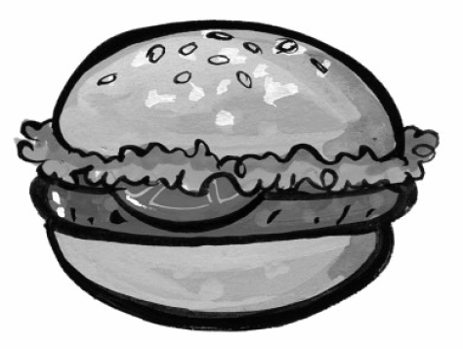



**➁Write the questions and answers.** Mark / 5

➊ sausage? / a / Would / like / you

Would you like a sausage?

➋ I’d / Yes, / one. / love

____________________________________

➌ some / Can / lemonade? / have / I

____________________________________

➍ are. / you / Here

____________________________________

➎ some / Would / like / watermelon? / you

____________________________________

➏ you. / No / thank

____________________________________

Total unit mark / 10